df command in Linux with Examples

What is df Command in Linux?
disk free also known as `df`, which is a powerful utility that provides valuable information on disk space utilization.
The df command displays information about file system disk space usage on the mounted file system.
This command retrieves the information from `/proc/mounts` or
`/etc/mtab`.
By default, df command shows disk space in Kilobytes (KB) and uses the SI unit suffixes (e.g, M for megabytes, G for gigabytes) for clarity.

Syntax of `df` command in Linux
The basic syntax of df is:

df [options] [filesystems]

Here,
options: These are optional flags that modify the output of the command.
filesystems: You can specify specific filesystems (mount points) to check their usage instead of getting information for all mounted drives.

If no file name is given, it displays the space available on all currently mounted file systems.

For example:

df

This will display information about all the mounted file systems which will include total size, used space, usage percentage, and the mount point.
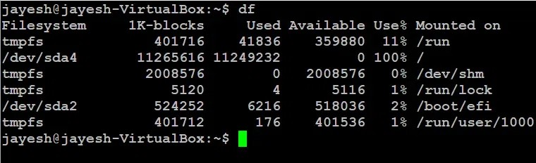
df
This command displays a table with columns for:
Filesystem: The name of the mounted storage device (e.g., /dev/sda4). Size: The total size of the filesystem in bytes.
Used: The amount of space currently occupied by data in bytes. Avail: The amount of free space available in bytes.
Use%: The percentage of the filesystem used.
Mounted on: The directory where the filesystem is mounted (e.g., /, /home).

Now, if you specify a particular file, then it will show the mount information of that particular file.

For example:

df jayesh.txt

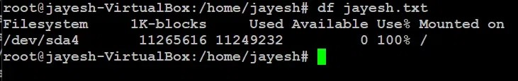
df jayesh.txt
You can replace `jayesh.txt` with the desired file name

Options Available in `df` command in Linux

Options | Description
'-a' or '--all' | Includes pseudo, duplicate, and inaccessible file systems in the output.
'-B <SIZE>' or '--block-size=  <SIZE>' | Scales sizes by SIZE before printing them.
'-h' or '--human-readable' | Prints sizes in a human-readable format using power of 1024.
'-H' or '--si' | Prints sizes in a human-readable format using power of 1000.
'-i' or '--inodes' | Lists inode information instead of block usage.
'-l' or '--local' | Limits listing to local file systems.
'-P' or '--portability' | Uses POSIX output format for better portability.
'--sync' | Invokes sync before getting usage info.

Options | Description
'--total' | Elides all entries insignificant to available space and produces a grand total.
'-t <TYPE>' or '--type=<TYPE>' | Limits listing to file systems of type TYPE.
'-T' or '--print-type' | Prints file system type

Usage and Implementation of df command in Linux

`-a` option in `df` command in Linux

If you want to display all the file system, use -a option.

df -a
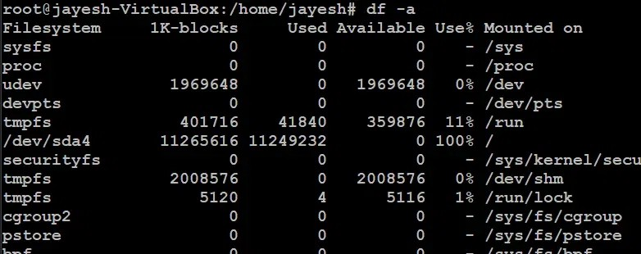
df -a

`-h` or `-H` option in `df` command in Linux

Use -h option to display size in power of 1024

df -h jayesh.txt

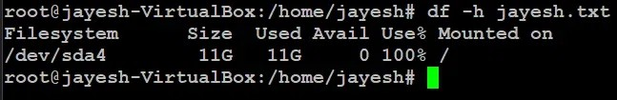
df -h jayesh.txt
Use -H option to display sizes in power of 1000

df -H jayesh.txt
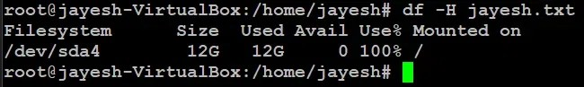
df -H jayesh.txt

`--total` option in `df` command in Linux

To get complete grand total, use --total option

df --total
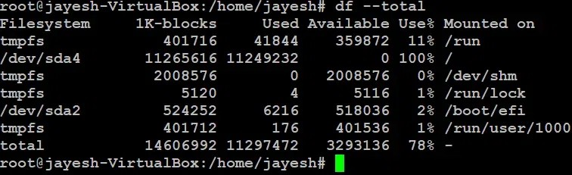
df --total

`-T` option in `df` command in Linux.

Use -T option to display file type For example:
df -T jayesh.txt

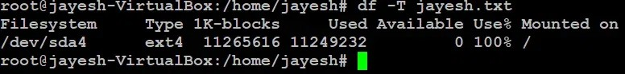
df -T jayesh.txt
You can see the file type for `jayesh.txt` is ext4

`--help` option in `df` command in Linux

And for more help, you can use --help option.

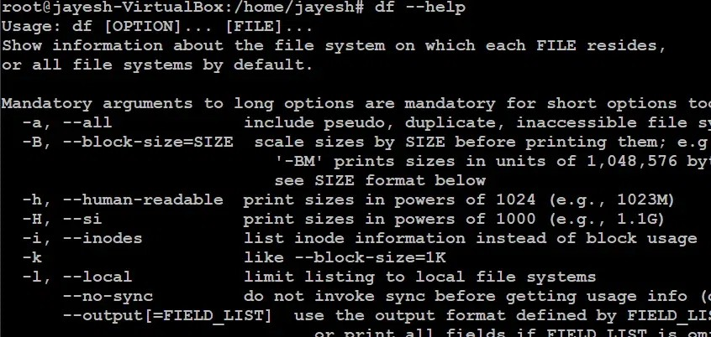
df --help

df --help

`-x` option in `df` command in Linux

Exclude specific file system types from the output For Example: tmpfs
df -x tmpfs
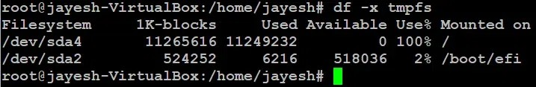
df -x tmpfs

